**Kaerrie Hall Samples**

**Sample CTA: Michigan State Direct Mail Campaign**

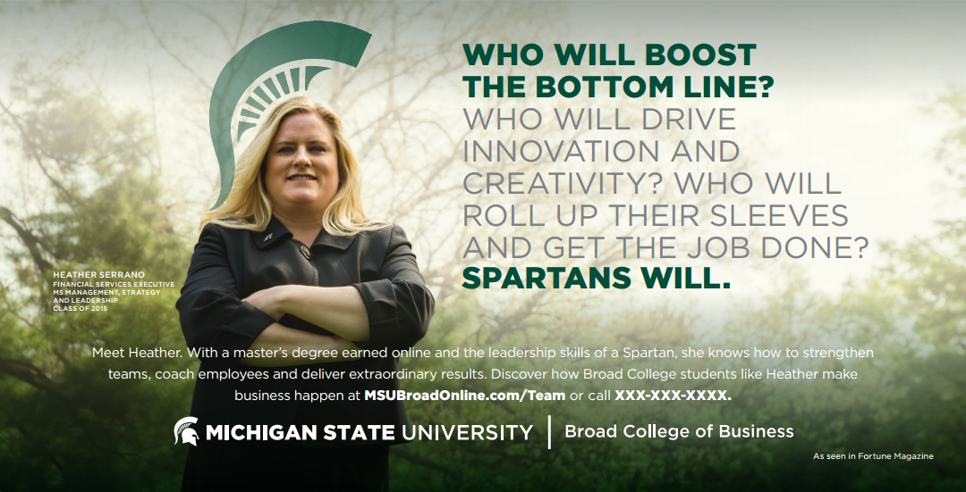

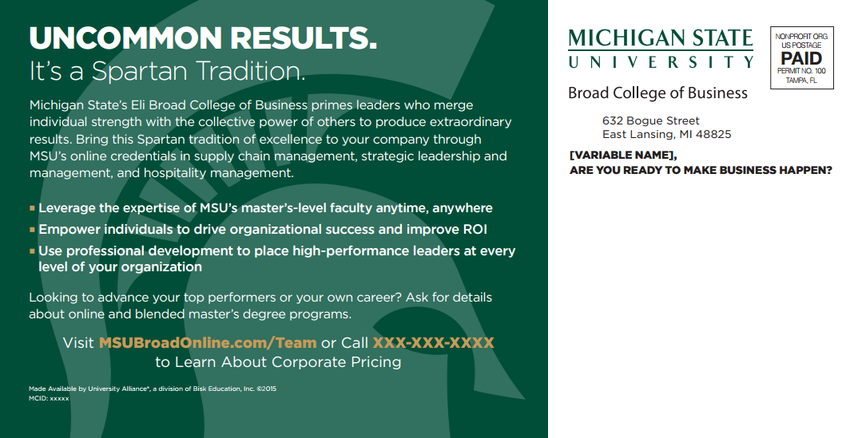

**Sample CTA: Michigan State Email**

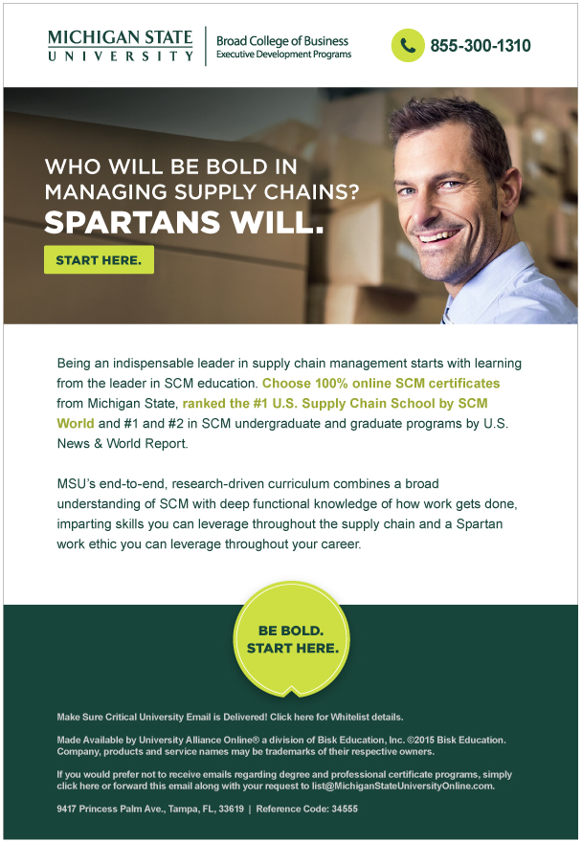

**Sample CTA: Michigan State Ad**

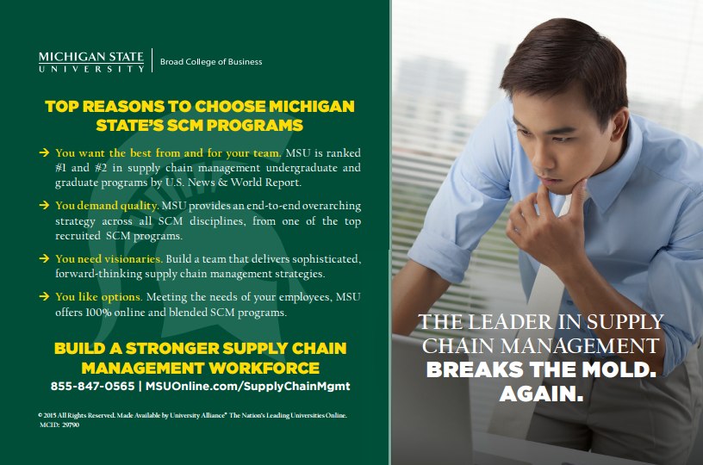

**Sample CTA: University of San Francisco Email**



**CTA Sample: Michigan State Ad**

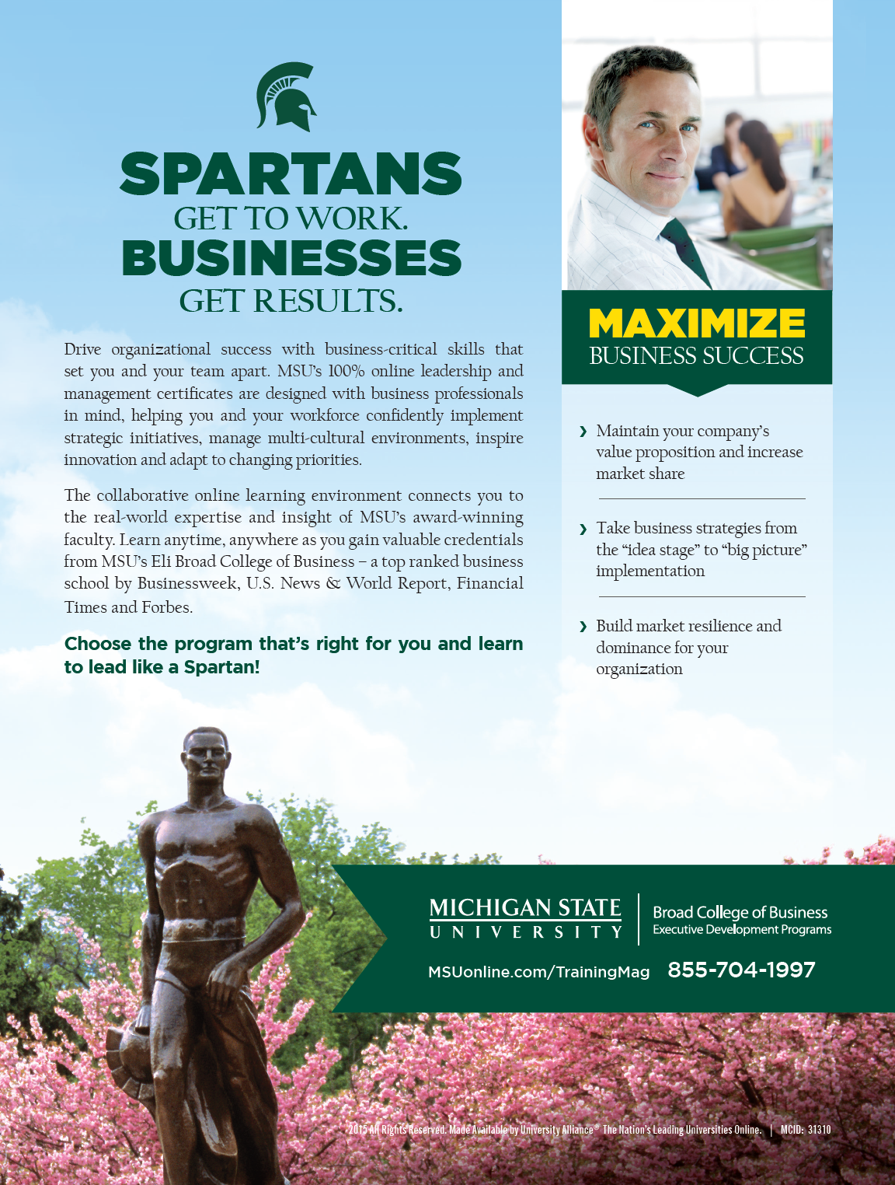

**Writing Sample with CTAs: Promotion of entrepreneurial workshop for Whitney**

(Logo)

Dream It – Do It!™   
The Workshop for Entrepreneurs!

Spending three days with us can lead to a lifetime of success. It all starts with “The Power of Your Word” (POW) workshop where individuals or teams from companies of all sizes learn how to creatively fulfill their business goals and entrepreneurial visions. Coming to [Location and Dates], this 3-day workshop helps you develop the skills and attitude that can produce unprecedented business results and transform ordinary people into extraordinary entrepreneurs.

CTA options:

I’m inspired! Tell me more.

I’m ready! Tell me more.

Become a leader in life! Register now.

[Form fields]

**CTA Samples: CTAs for sales training programs for wireless retailers**

Get strategies that work from day one

Boost the sales IQ of your team starting today

Ordinary training programs inspire naps. Ours inspires action!

Get your team fit for sales in 7 proven steps

Turn your sales force into a dream team in 7 proven steps

These mistakes cost you money. This sales training can stop them.

Make your life easier. Make more money. Make the call!

Break sales records with breakthrough training

Click here to get our free report on what works and what doesn’t in wireless retail training

Add this to your success tool kit – Get a free sneak peek now!

**CTA Samples: CTAs for mystery shopping services**

Ever wonder what goes on in your stores when you’re not there? See what they see with customer experience reports. View a free sample now.

In a business where everyone is counting on you, count on us! View a free sample report now.

See your stores from an entirely new perspective. View a free sample report now.

Schedule a “shop” and see what your customers see

Get a new perspective from an unbiased source. Call now!

**CTA Samples: CTAs for miscellaneous as noted**

(promoting Ababall): Download arcade-style mayhem for your Palm OS device!

(promoting Make the Pitch sales training): Make presentations that persuade! Sign up for training today.

(promoting leadership training from Michigan State): Lead like a Spartan!

(promoting sales training for handling objections): Turn objections into sales! Sign up for training today.

(promoting a book through direct mail piece): We asked the nation’s leading direct marketers how they drive up response. Their recommendations are yours – free!

(promoting a foreclosure training seminar): This is your chance to finally get the straight talk on changing your financial future. Call now!

(promoting a real estate rehab/flipping program): Get the edge that turns problems into profits! Attend our free seminar.

**Additional Samples**

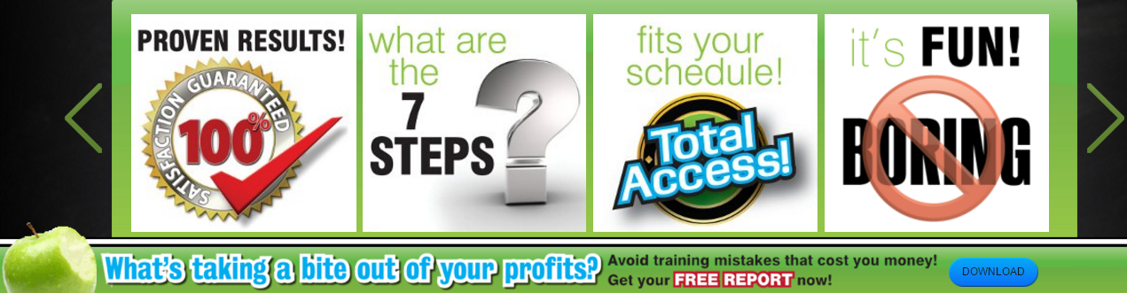



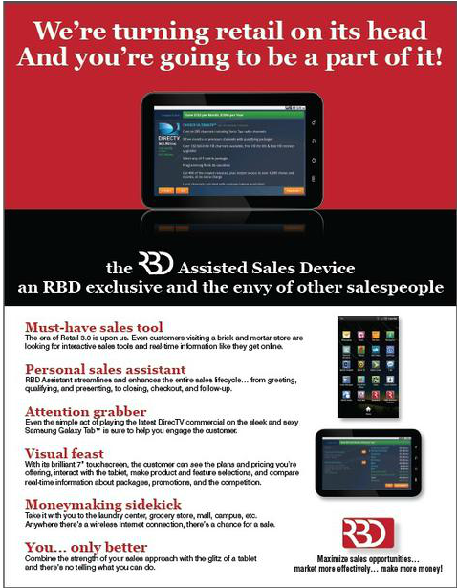

**CTA Sample: RBD Mastering Wireless Sales Promotion on Website**

